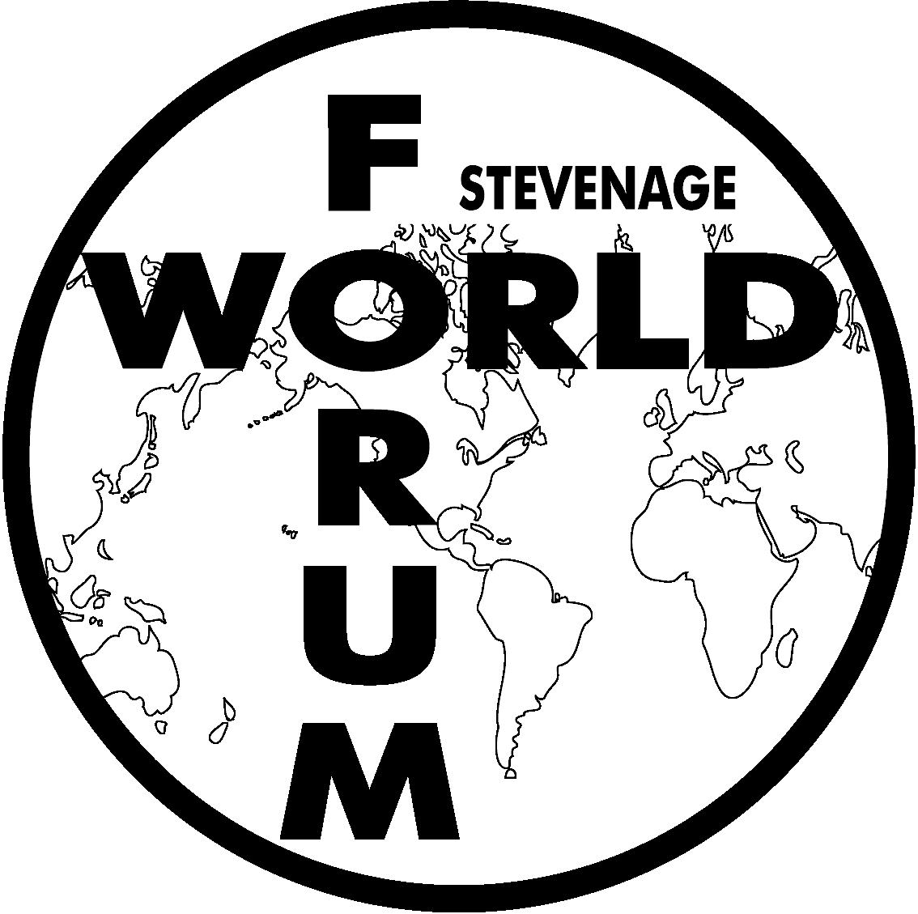

Stevenage World Forum for Ethnic Communities

Annual Review

2021-2022

Vision:

Support vibrant BME communities

Mission:
We exist to advocate equal access to services for all



Background:
Stevenage World Forum (SWF) for Ethnic Communities was officially constituted at a public meeting held on 10 October 2000.

We are based in the Sherma Batson Centre in Bedwell, Stevenage, Hertfordshire. The building was converted from garages into a purpose-built centre with a grant from the Active Communities Unit and in partnership with Volunteer Centre Stevenage (VCS). The Centre has been managed by us since April 2006.

Why was the Forum Established?
- To give the ethnic communities a voice and act as a representative body in communicating with other organisations and consultative groups (statutory and voluntary) and ensure they are not left out of decision-making processes.
- To raise issues of concern and develop proposals and practical initiatives to make services more accessible in partnership with statutory and voluntary bodies.
- To encourage networking, amongst ethnic groups and share and celebrate cultural diversity.
- To develop projects to meet the needs of ethnic communities and mixed heritage families of Stevenage.
- To enable people to share knowledge and good practices.
- To break down barriers caused by ignorance and encourage mutual respect.
- To work towards establishing a multi-cultural centre for educational purposes, social activities, meetings or worship or fair access to existing community space.

Our charitable objects are:
- Exists to address the needs and aspirations of the minority ethnic communities of Stevenage, and surrounding areas and to support these communities to achieve their goals
- Aims to improve the quality of life, fulfil potential and enhance participation in the education, social, economic, and cultural life of the Borough
- Endeavours to achieve this by fostering understanding across all communities and by working in partnership with statutory providers and the voluntary sector

SWF shall be non-party in politics and non-sectarian in religion.

Our Values: Respect, Equality, Open and inclusive

What do we do?
We support ethnic community groups by building their capacity through provision of resources and assistance within the boundaries of our funding.

We do this by offering the following services:
- Administrative assistance (including photocopying)
- Contact/Mailing address (including fax, phone, email, website space)
- Meeting spaces
- Internet Access
- Assist other organisations to make their activities more accessible to members of Black and Minority Ethnic communities
- Manage accounts for member groups
- Provide training

As a Board: Code of Governance (Charity Commission)
- Training session on the seven principles was undertaken
- It was agreed that the best process for us, was that each Trustee would review the principles as an individual and the feedback would be collated and reviewed at a Board meeting
- The review has been delayed due to the health pandemic and capacity of the Trustees
- The Board will review the process in 2021/2022

Our story for 2021/2022

International Women’s Day:
This event was organised by Stevenage World Forum in collaboration with Soroptimists International Hertford and District Club. Tom Pena gave a talk and demo on situational awareness which was very well received by the audience, followed by table discussions on a series of questions. Very insightful discussions on the tables on gender equality and how being a woman currently means to them.

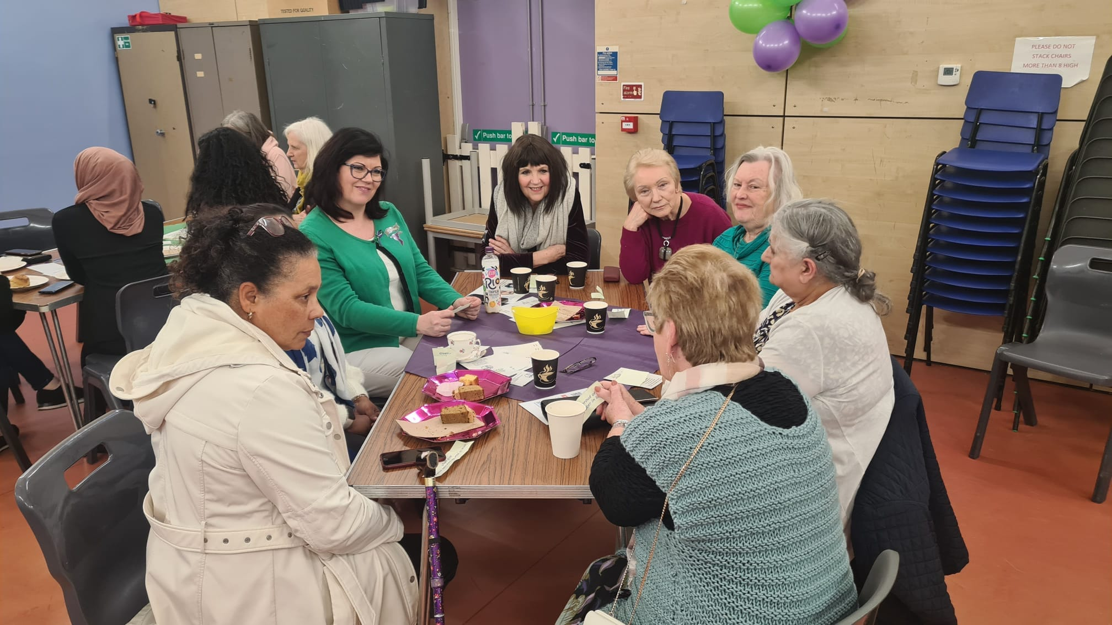
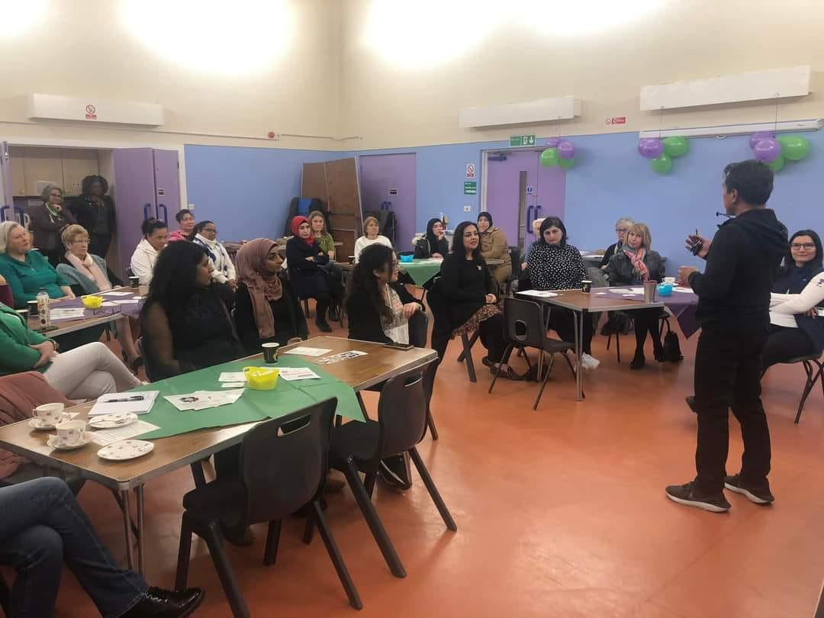
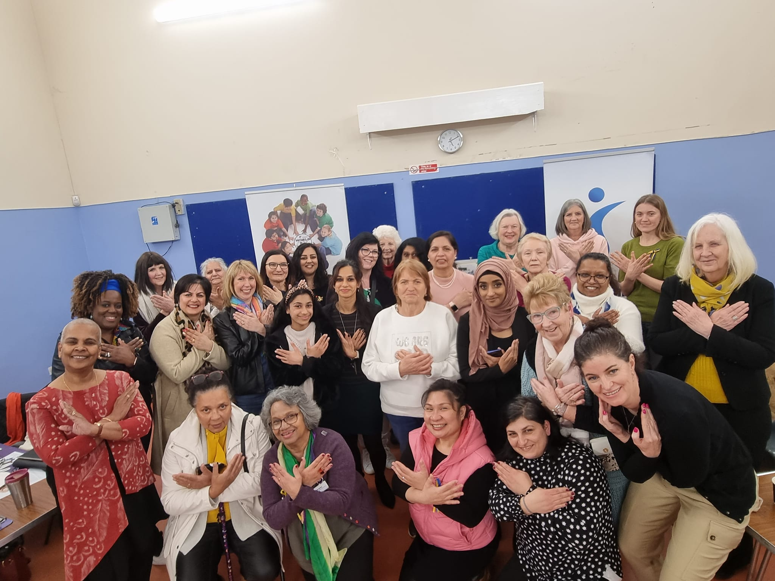
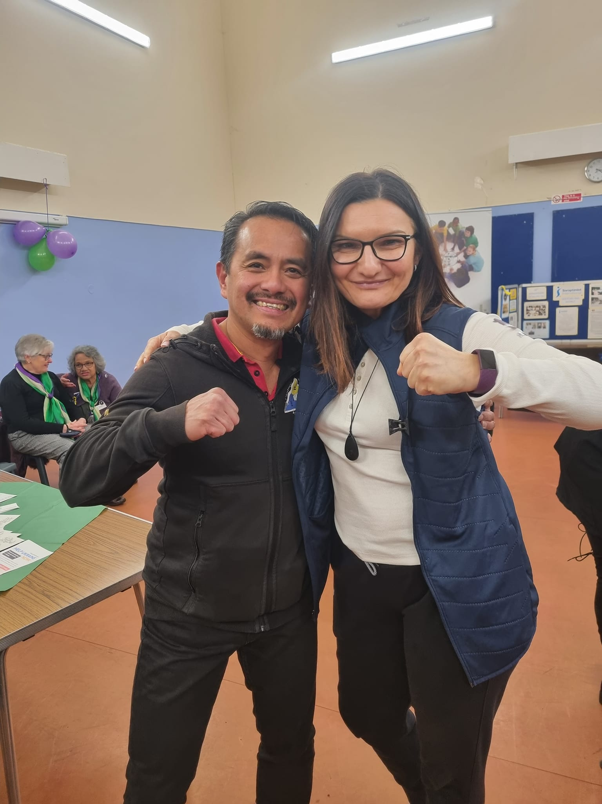
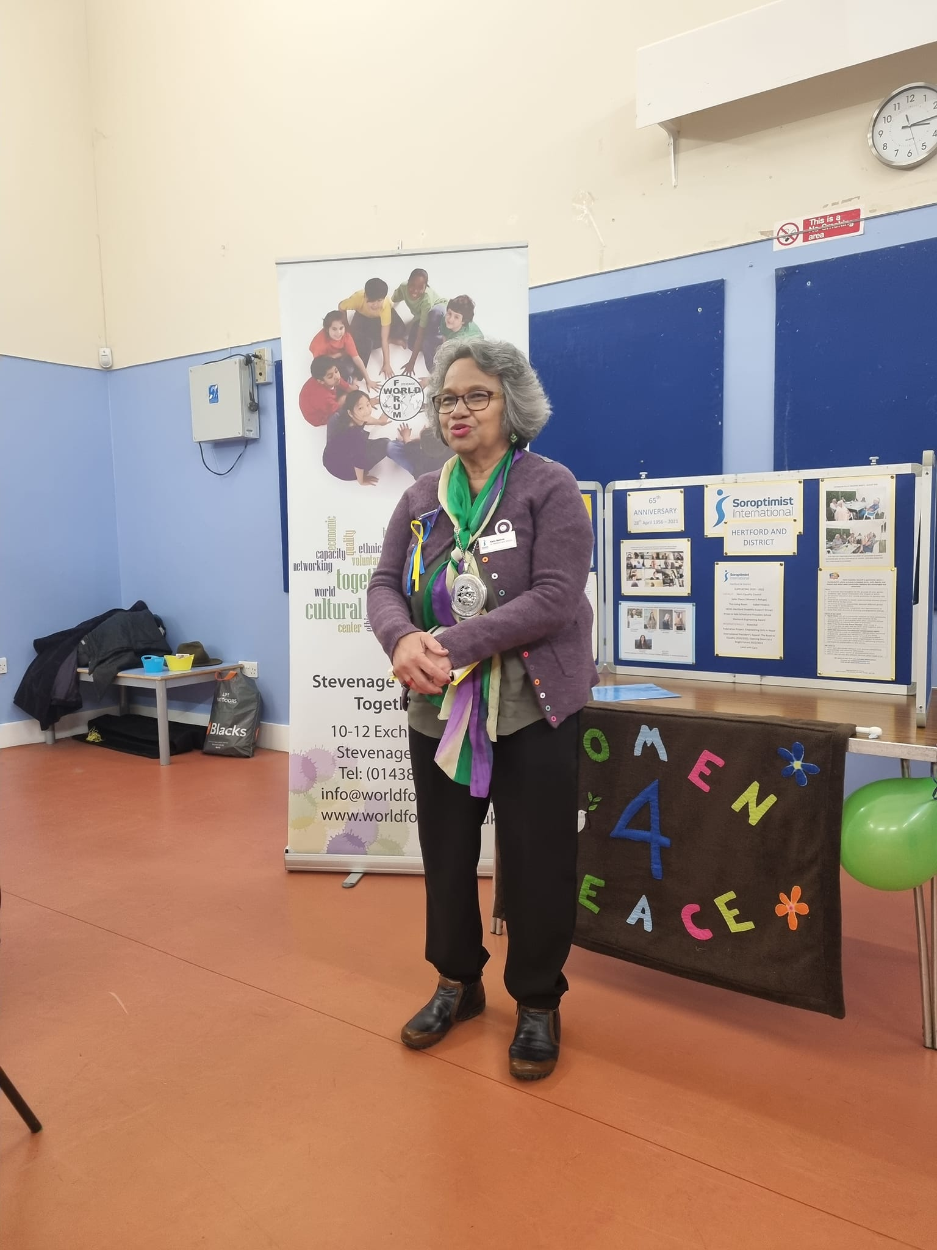
St Nicholas Day Celebrations:
Stevenage World Forum hosted a stall at the St Nicholas Centre to celebrate St Nicholas Day. It was a well-received event attended by the various communities in Stevenage.
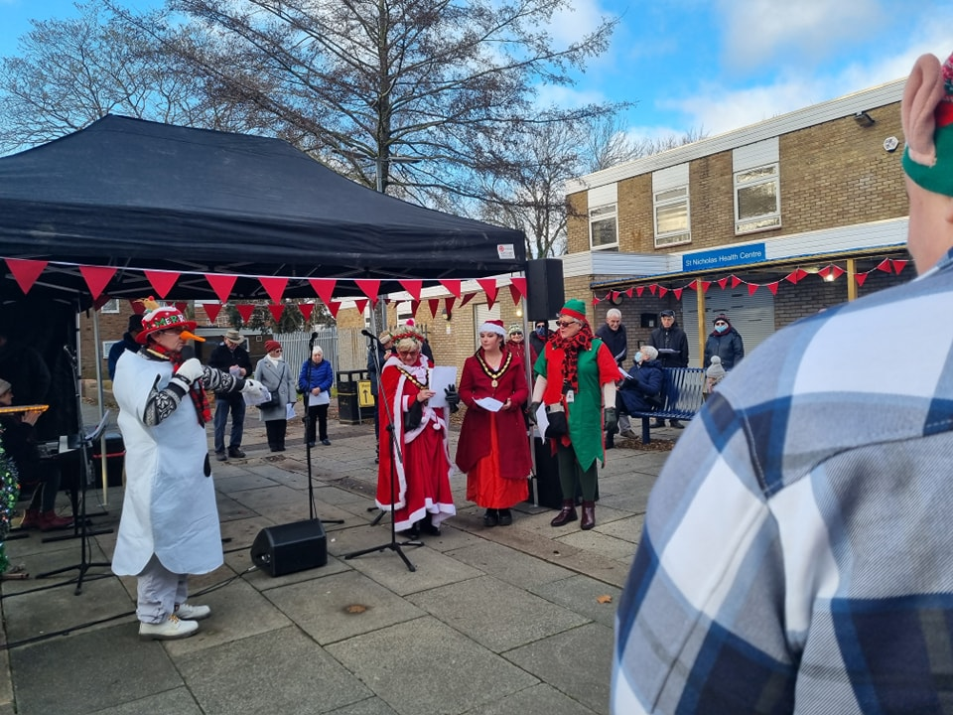
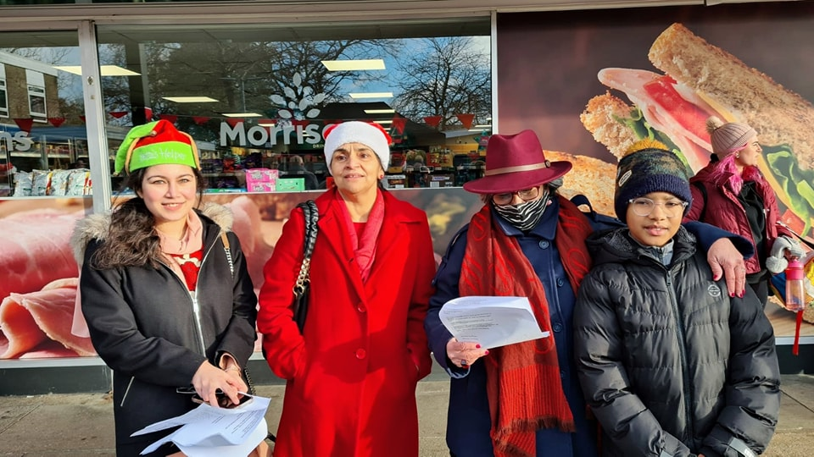
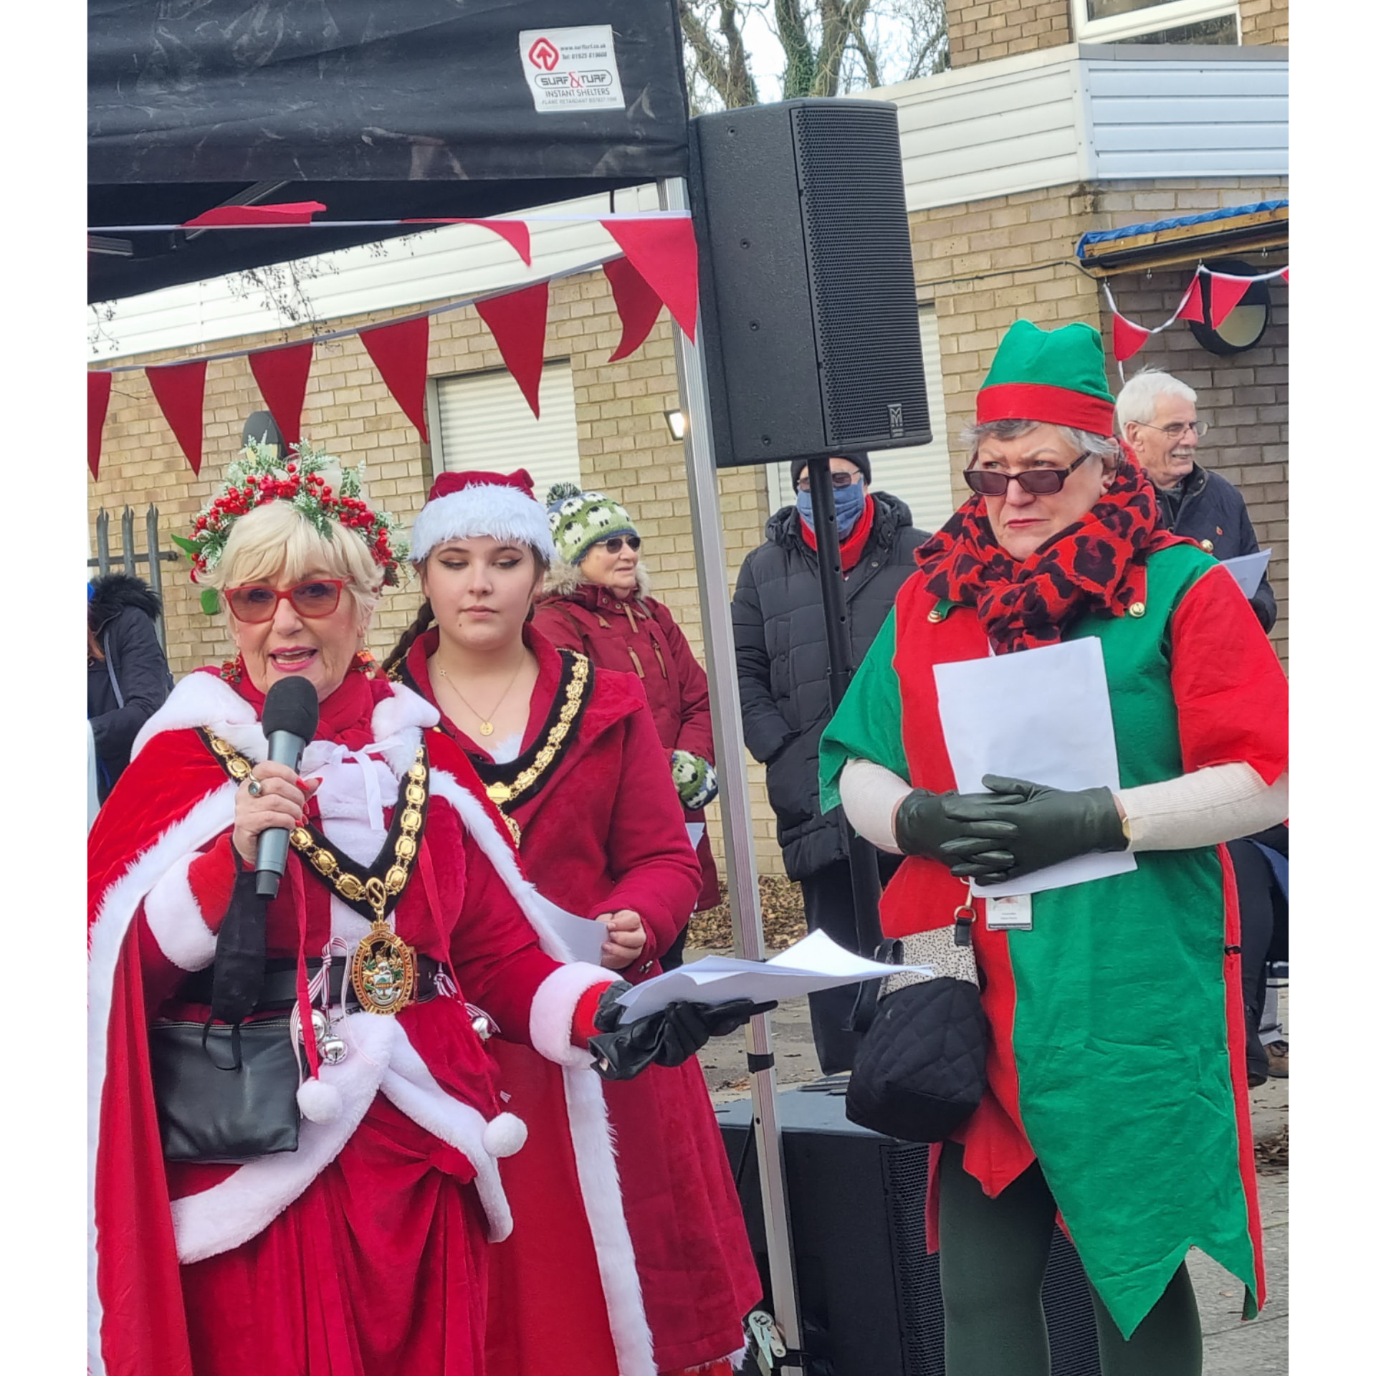
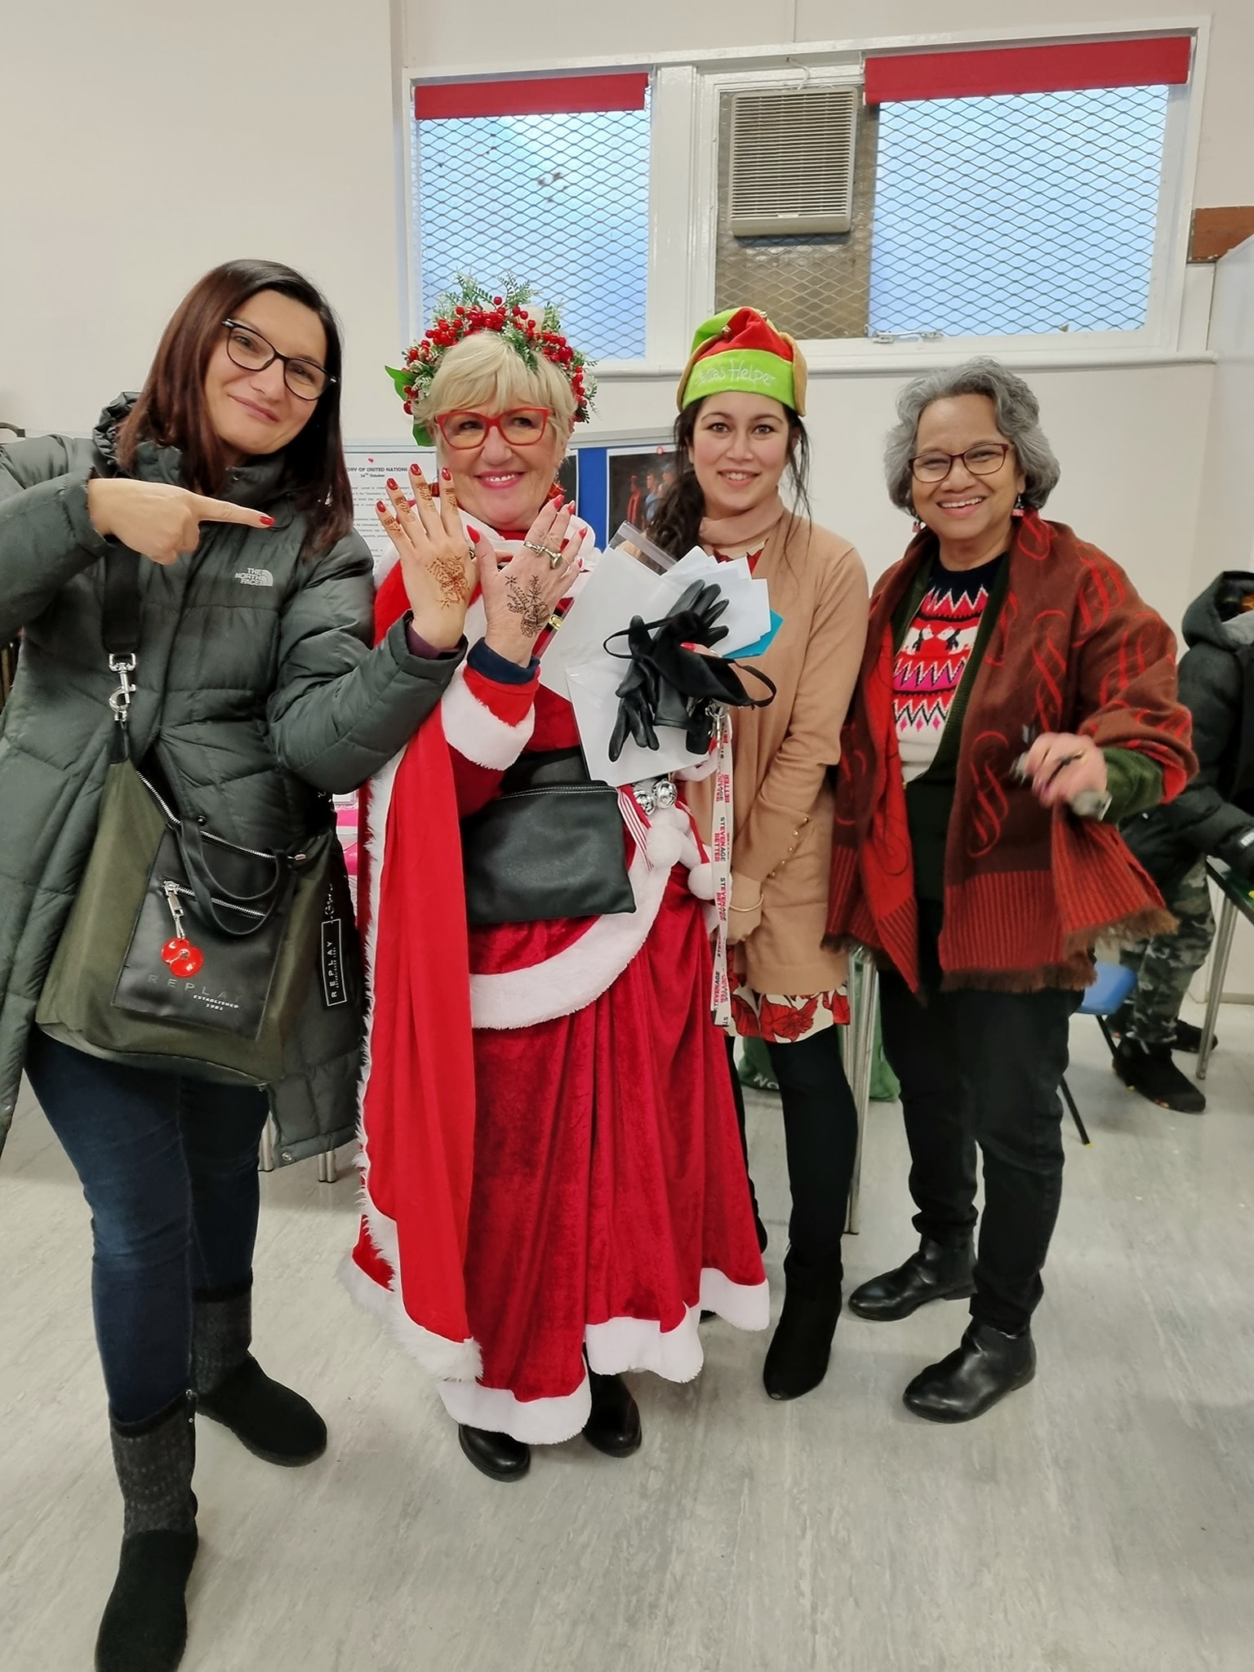
Ukraine Solidarity:
Stevenage World Forum continues to stand in solidarity with Ukraine. It was great to see members of Stevenage Borough Council, various distinguished speakers and community organisations present at the Town Centre Square in tribute to the people of Ukraine.
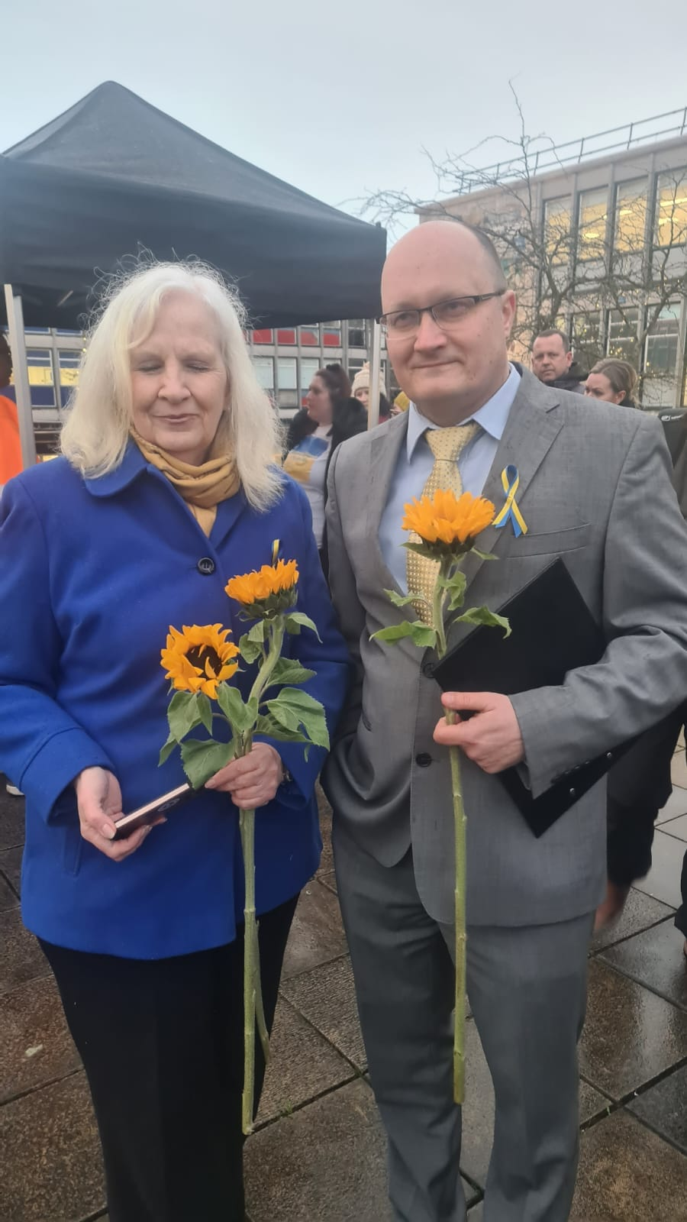
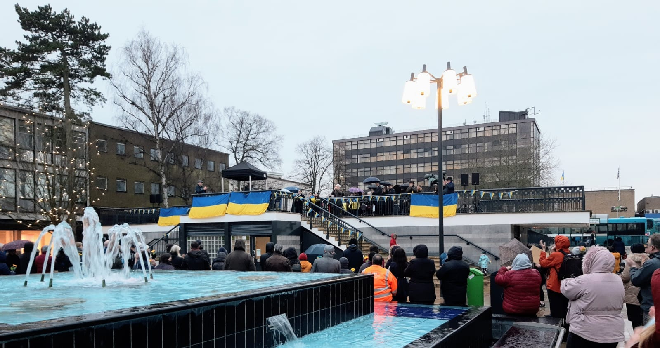
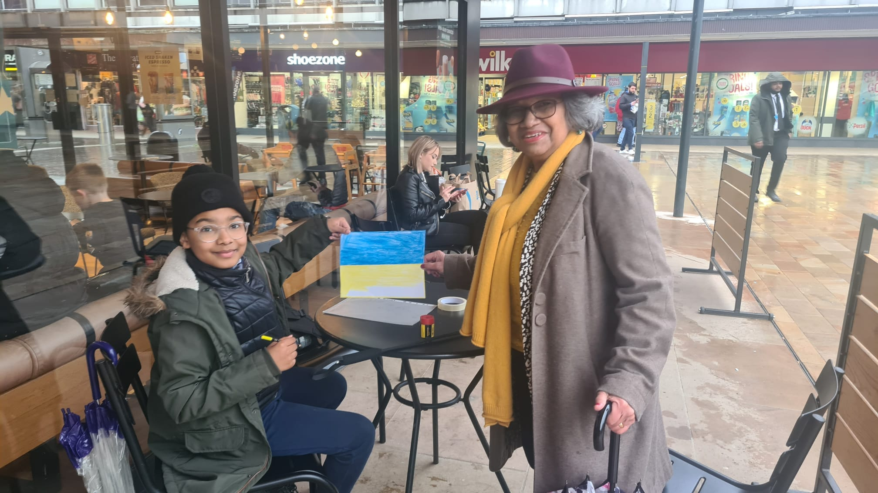
Stevenage Legacy and Resilience:
Further to the project delivered last year, we were successful with another grant from Hertfordshire Community Foundation. This part two project was delivered by working in partnership with BeMe. The project targeted people from the Black communities with keynote speakers from the communities discussing the impact of covid, value of vaccination and impact of mental health issues for the families.

Stevenage Equalities Commission
We were delighted to be an active Commissioner on this pioneering project set by Stevenage Borough Council, with Errol John as its Chair. The agreed four areas which needed the diverse stakeholders not only from Stevenage to talk and discuss the issues and concerns expressed by the local communities of interest. The four areas are Education; health; criminal justice and employment/business.

Healthy Eating Project
We were approached by the Project Approach Manager, Public Health, Hertfordshire County Council, to work with Shephall Health Centre. The initiative is to collaborate with patients from the Black community who are at risk of early diabetes, cardiovascular and hypertension. This is a 12-week course.

We developed a partnership with Sporting Inspirations, who are the new Centre Managers of Stoneyhall Community Centre. We held an open day with a view to raise awareness of culturally prepared healthy meals, cooked by a Caribbean chef and how to keep active through different ideas on how to exercise.

This project has been delayed as the referrals from the Health Centre are a work in progress. Shephall Health Centre has now extended the offer to three other Primary Care Networks, and we look forward to continuing working with Public Health Officer and the three health centres.

Celebrate!!!
Working in collaboration with the team lead, Michelle Gardner, we will be reviewing the format and structure in 2022.

Stevenage International Day
We were delighted to join in the celebrations in the Town Centre. We were visited by many “old friends” and managed to enrol many new friends. It was a lovely joyous event with great music, food and raised awareness of our work.

Local and vital partnerships:
- Healthy Stevenage Partnership
- Junction 7 Creatives: John Prebble
- Older people’s forum
- SBC Councillor John Garner for his insight and support
- Social Inclusion Partnership
- Stevenage Equalities Commission: Errol John
- Stevenage Legacy and Resilience

Social media has increased since the last AGM, we have 530 followers on Facebook, 204 followers on Instagram and 87 followers on Twitter.

Finance report: our income was £40,270 and our expenditure was £26,722. Our unrestricted reserves are £4,305 and restricted reserves are £23,102.

I want to thank everyone involved, especially the Trustees who have worked hard with the delivery of projects and to Naz Chowdhury, our community Connector. Plus, the highly active partnership with Cultural and Arts programme leads: Nick Mallinger, Stevenage Borough Council and John Prebble, Junction 7 Creatives.

Kate Belinis DL
Chair
BIG thanks to
Friends of SWF for their kind donations and time
Hertfordshire Community Foundation
Hertfordshire County Council: Adult Care Services and Public Health
Stevenage Legacy & Resilience Partnership
Irish Network Stevenage
Members of SWF
Stevenage Borough Councillors and Officers
Volunteers
Board of Trustees:
Chair Kate Belinis DL
Treasurer Carolina Cristina Veres
Secretary Charanjit Kang
Trustees Elaine Connolly
Gosia Poczatek
Imrana Chowdhury
Jasbir Jhajj
Juddy Otti
Luke Donovan
Peggy Lyons

SBC Councillor John Gardner

